# Exercises: Objects & Composition

Problems for exercises and homework for the ["JavaScript Advanced" course @ SoftUni](https://softuni.bg/trainings/3217/js-advanced-january-2021). Submit your solutions in the SoftUni judge system at <https://judge.softuni.bg/Contests/2759/Objects-and-Composition-Exercise>.

## Calorie Object

Write a function that composes an object by given properties. The input comes as an **array of strings**. Every **even index** of the array represents the **name of the food**. Every **odd index** is a **number** that is equal to the **calories in 100 grams of the given product**. Assign each value to its corresponding property, and finally print the object.

The **input** comes as an **array of string** **elements**.

The **output** should be printed on the console.

### Examples

|  |  |
| --- | --- |
| **Input** | **Output** |
| **['Yoghurt', '48', 'Rise', '138', 'Apple', '52']** | **{ Yoghurt: 48, Rise: 138, Apple: 52 }** |
| **['Potato', '93', 'Skyr', '63', 'Cucumber', '18', 'Milk', '42']** | **{ Potato: 93, Skyr: 63, Cucumber: 18, Milk: 42 }** |

## Construction Crew

Write a program that **receives** a worker **object** as a **parameter** and modifies its properties. Workers have the following structure:

{

weight: Number,

experience: Number,

levelOfHydrated: Number,

dizziness: Boolean

}

**Weight** is expressed in **kilograms**, **experience** in **years** and **levelOfHydrated** is in **milliliters**. If you receive a worker whose **dizziness** property is set to **true** it means he needs to intake some **water** in order to be able to work correctly. The required amount is 0.1ml per **kilogram** per year of **experience**. The required amount must be **added** to the **existing amount (to the levelOfHydrated)**. Once the water is administered, change the **dizziness** property to **false**.

Workers who **do not have dizziness** should **not** be modified in any way. Return them as they were.

### Input

Your function will receive a valid **object** as a **parameter**.

### Output

Return the **same object** that was passed in, **modified** as necessary.

### Examples

|  |  |
| --- | --- |
| Input | Output |
| { weight: 80,  experience: 1,  levelOfHydrated: 0,  dizziness: true } | { weight: 80,  experience: 1,  levelOfHydrated: 8,  dizziness: false } |
| { weight: 120,  experience: 20,  levelOfHydrated: 200,  dizziness: true } | { weight: 120,  experience: 20,  levelOfHydrated: 440,  dizziness: false } |
| { weight: 95,  experience: 3,  levelOfHydrated: 0,  dizziness: false } | { weight: 95,  experience: 3,  levelOfHydrated: 0,  dizziness: false } |

## Car Factory

Write a program that assembles a car by **given requirements** out of **existing** **components**. The client will place an order in the form of an **object describing** the car. You need to **determine** which parts to use to fulfill the client’s order. You have the following parts in storage:

An **engine** has **power** (given in horsepower) and **volume** (given in cubic centimeters). Both of these values are **numbers**. When selecting an engine, pick the **smallest possible** that still meets the requirements.

Small engine: { power: 90, volume: 1800 }

Normal engine: { power: 120, volume: 2400 }

Monster engine: { power: 200, volume: 3500 }

A **carriage** has a **type** and **color**. Both of these values are **strings**. You have two types of carriages in storage and can paint them **any color**.

Hatchback: { type: 'hatchback', color: <as required> }

Coupe: { type: 'coupe', color: <as required> }

The **wheels** will be represented by an **array** of 4 **numbers**, each number represents the **diameter** of the wheel in inches. The size can only be an **odd number**. Round **down** any requirements you receive to the nearest odd number.

### Input

You will receive an **object** as an **argument** to your function. The format will be as follows:

{ model: <model name>,

power: <minimum power>,

color: <color>,

carriage: <carriage type>,

wheelsize: <size> }

### Output

**Return** the resulting car **object** as a result of your function. See the examples for details.

### Examples

|  |  |
| --- | --- |
| Sample input | Output |
| { model: 'VW Golf II',  power: 90,  color: 'blue',  carriage: 'hatchback',  wheelsize: 14 } | { model: 'VW Golf II',  engine: { power: 90,  volume: 1800 },  carriage: { type: 'hatchback',  color: 'blue' },  wheels: [13, 13, 13, 13] } |
| { model: 'Opel Vectra',  power: 110,  color: 'grey',  carriage: 'coupe',  wheelsize: 17 } | { model: 'Opel Vectra',  engine: { power: 120,  volume: 2400 },  carriage: { type: 'coupe',  color: 'grey' },  wheels: [17, 17, 17, 17] } |

## Heroic Inventory

In the era of heroes, every hero has his own items which make him unique. Create a function that creates a **register for the heroes**, with their **names**, **level**, and **items**, if they have such. The register should accept data in a specified format, and return it presented in a specified format.

### Input

The **input** comes as an array of strings. Each element holds data for a hero, in the following format:

"{heroName} / {heroLevel} / {item1}, {item2}, {item3}..."

You must store the data about every hero. The **name** is a **string**, a **level** is a **number** and the items are all **strings.**

### Output

The **output** is a **JSON representation** of the data for all the heroes you’ve stored. The data must be an **array of all the heroes**. Check the examples for more info.

### Examples

|  |  |
| --- | --- |
| **Input** | **Output** |
| **['Isacc / 25 / Apple, GravityGun',**  **'Derek / 12 / BarrelVest, DestructionSword',**  **'Hes / 1 / Desolator, Sentinel, Antara']** | [{"name":"Isacc","level":25,"items":["Apple","GravityGun"]},{"name":"Derek","level":12,"items":["BarrelVest","DestructionSword"]},{"name":"Hes","level":1,"items":["Desolator","Sentinel","Antara"]}] |
| **['Jake / 1000 / Gauss, HolidayGrenade']** | [{"name":"Jake","level":1000,"items":["Gauss","HolidayGrenade"]}] |

### Hints

* We need an array that will hold our hero data. That is the first thing we create.



* Next, we need to loop over the whole input, and process it. Let’s do that with a simple for loop.

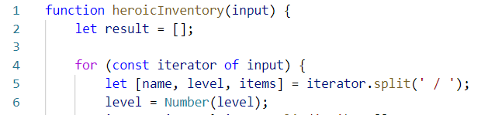

* Every element from the input holds data about a hero, however, the **elements from the data** we need are **separated by some delimiter**, so we just split each string with that **delimiter**.
* Next, we need to take the elements from the **string array**, which is a result of the **string split**, and by destructuring assignment syntax we assign the array properties. Don’t forget to parse the number.
* However, here we remember there is something special about the items, so read the problem definition again, you will notice that there might be a **case** where the hero **has** **no items**; in that case, using **destructuring** is ok and when there are no items, our property items will be undefined and trying to spit it will throw an error. That is why we need to perform a simple check using the [ternary operator](https://developer.mozilla.org/en-US/docs/Web/JavaScript/Reference/Operators/Conditional_Operator).



* If **there are any items** in the **input**, the **variable** will be set to the **split version of them**. If not, it will just be set to an **empty array**.
* We have now extracted the needed data – we have stored the **input name** in a **variable**, we have parsed the **given level** to a **number**, and we have also **split** the **items** that the **hero holds** by their **delimiter**, which would result in a **string array** of elements. By definition, the **items** are **strings**, so we don’t need to process the array we’ve made anymore.
* Now what is left is to add that data into **an object** and **add** that object to the **array**.

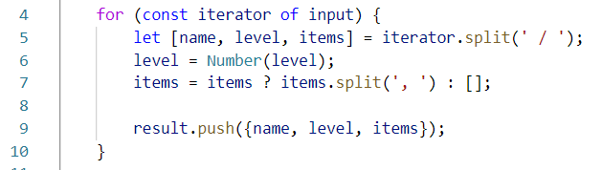

* Lastly, we need to turn the array of objects we have made, into a JSON string, which is done by the JSON.stringify() function



## Lowest Prices in Cities

You will be given several towns, with products and their price. You need to find **the lowest price** for **every product** and **the town it is sold at** for that price.

### Input

The **input** comes as an array of strings. Each element will hold data about a **town**, **product**, and **its price** at that town. The **town** and **product** will be **strings**, the **price** will be a **number**. The input will come in the following format:

{townName} | {productName} | {productPrice}

### Output

As **output**, you must print **each** **product** with its **lowest price** and **the town** at which the product is **sold at that** **price**. If **two towns share** the **same lowest price**, print the one that was **entered first**.   
The output, for every product, should be in the following format:

{productName} -> {productLowestPrice} ({townName})

The **order of output** is - **order of entrance**. See the examples for more info.

### Examples

|  |  |
| --- | --- |
| **Input** | **Output** |
| **['Sample Town | Sample Product | 1000',**  **'Sample Town | Orange | 2',**  **'Sample Town | Peach | 1',**  **'Sofia | Orange | 3',**  **'Sofia | Peach | 2',**  **'New York | Sample Product | 1000.1',**  **'New York | Burger | 10']** | **Sample Product -> 1000 (Sample Town)**  **Orange -> 2 (Sample Town)**  **Peach -> 1 (Sample Town)**  **Burger -> 10 (New York)** |

## Store Catalogue

You have to create a sorted catalogue of store products. You will be given the products’ names and prices. You need to order them by **alphabetical order**.

### Input

The **input** comes as an array of strings. Each element holds info about a product in the following format:

"{productName} : {productPrice}"

The **product’s name** will be a **string**, which will **always** **start with a capital letter**, and the **price** will be **a number**. There will be **NO duplicate product input**. The comparison for alphabetical order is **case-insensitive**.

### Output

As **output**, you must print all the products in a specified format. They must be ordered **exactly as specified above**. The products must be **divided into groups**, by the **initial of their name**. The **group’s initial should be printed**, and after that the products should be printed with **2 spaces before their names**. For more info check the examples.

### Examples

|  |  |  |  |  |
| --- | --- | --- | --- | --- |
| **Input** | **Output** |  | **Input** | **Output** |
| **['Appricot : 20.4',**  **'Fridge : 1500',**  **'TV : 1499',**  **'Deodorant : 10',**  **'Boiler : 300',**  **'Apple : 1.25',**  **'Anti-Bug Spray : 15',**  **'T-Shirt : 10']** | **A**  **Anti-Bug Spray: 15**  **Apple: 1.25**  **Appricot: 20.4**  **B**  **Boiler: 300**  **D**  **Deodorant: 10**  **F**  **Fridge: 1500**  **T**  **T-Shirt: 10**  **TV: 1499** |  | **['Banana : 2',**  **'Rubic's Cube : 5',**  **'Raspberry P : 4999',**  **'Rolex : 100000',**  **'Rollon : 10',**  **'Rali Car : 2000000',**  **'Pesho : 0.000001',**  **'Barrel : 10']** | **B**  **Banana: 2**  **Barrel: 10**  **P**  **Pesho: 0.000001**  **R**  **Rali Car: 2000000**  **Raspberry P: 4999**  **Rolex: 100000**  **Rollon: 10**  **Rubic's Cube: 5** |

## Towns to JSON

You're tasked to create and print a JSON from a text table. You will receive input as an array of strings, where each string represents a row of a table, with values on the row encompassed by pipes **"|"** and optionally spaces. The table will consist of exactly 3 columns **"Town"**, **"Latitude"** and **"Longitude"**. The **Latitude** and **Longitude** columns will always contain **valid numbers**. Check the examples to get a better understanding of your task.

### Input

The **input** comes as an array of strings – the first string contains the table’s headings, each next string is a row from the table.

### Output

* The **output** should be an array of objects wrapped in **JSON.stringify()**.
* **Latitude** and **Longitude** must be parsed to **numbers,** and represented till the **second digit after the decimal point**!

### Examples

|  |  |
| --- | --- |
| **Input** | **Output** |
| **['| Town | Latitude | Longitude |',**  **'| Sofia | 42.696552 | 23.32601 |',**  **'| Beijing | 39.913818 | 116.363625 |']** | **[{"Town":"Sofia",**  **"Latitude":42.7,**  **"Longitude":23.32**  **}, {"Town":"Beijing",**  **"Latitude":39.91,**  **"Longitude":116.36**  **}]** |
| **['| Town | Latitude | Longitude |',**  **'| Veliko Turnovo | 43.0757 | 25.6172 |',**  **'| Monatevideo | 34.50 | 56.11 |']** | **[{"Town":"Veliko Turnovo",**  **"Latitude":43.08,**  **"Longitude":25.62**  **}, {"Town":"Monatevideo",**  **"Latitude":34.5,**  **"Longitude":56.11**  **}]** |

## Rectangle

Write a **function** that creates and returns a rectangle object. The rectangle needs to have **width** (Number), **height** (Number), and **color** (String) properties, which are set via arguments during creation, and a calcArea() method, that calculates and **returns** the rectangle’s area.

### Input

The function will receive three valid parameters – **width** (Number), **height** (Number), and **color** (String).

### Output

Your function must return an object with all properties and methods as described. The calcArea() method of the object should **return** a number. The first letter in the color must be **upperCase().**

### Examples

|  |  |
| --- | --- |
| Sample Input | Output |
| let rect = rectangle(4, 5, 'red');  console.log(rect.width);  console.log(rect.height);  console.log(rect.color);  console.log(rect.calcArea()); | 4  5  Red  20 |

## Sorted List*

Create a function that returns a special **object**, which **keeps** a list of numbers, sorted in **ascending order**. It must support the following functionality:

* **add(element)** - adds a new element to the collection
* **remove(index)** - removes the element at position **index**
* **get(index)** - returns the value of the element at position **index**
* **size** - number of elements stored in the collection

The **correct order** of the elements must be kept **at all times**, regardless of which operation is called. **Removing** and **retrieving** elements **shouldn’t** **work** if the provided index points **outside the length** of the collection (either throw an error or do nothing). Note the **size** of the collection is **not** a function.

### Input / Output

The initial function takes no arguments and must **return** an **object**.

All methods on the object that expect **input** will receive data as **parameters**. Methods that have **validation** will be tested with both **valid and invalid** data. Any result expected from a method should be **returned** as its result.

### Examples

|  |  |
| --- | --- |
| **Sample Input** | **Output** |
| **let list = createSortedList();**  **list.add(5);**  **list.add(6);**  **list.add(7);**  **console.log(list.get(1));**  **list.remove(1);**  **console.log(list.get(1));** | **6**  **7** |

## Heroes

Create a function that **returns** an **object** with 2 methods (**mage** and **fighter**). This object should be able to **create** heroes (fighters and mages). Every hero has a **state**.

* Fighters have a **name**, **health = 100** and **stamina = 100** and every fighter can fight. When he **fights** his **stamina** **decreases** by **1** and the following message is **printed** on the console:

**`${fighter's name} slashes at the foe!`**

* Mages also have state (**name**, **health = 100** and **mana = 100**). Every mage can **cast** **spells**. When a spell is cast the mage's **mana** **decreases** by **1** and the following message is **printed** on the console:

**`${mage's name} cast ${spell}`**

### Note:

For more information check the examples below.

|  |  |
| --- | --- |
| Input | Output |
| let create = solve();  const scorcher = create.mage("Scorcher");  scorcher.cast("fireball")  scorcher.cast("thunder")  scorcher.cast("light")  const scorcher2 = create.fighter("Scorcher 2");  scorcher2.fight()  console.log(scorcher2.stamina);  console.log(scorcher.mana); | **Scorcher cast fireball**  **Scorcher cast thunder**  **Scorcher cast light**  **Scorcher 2 slashes at the foe!**  **99**  **97** |

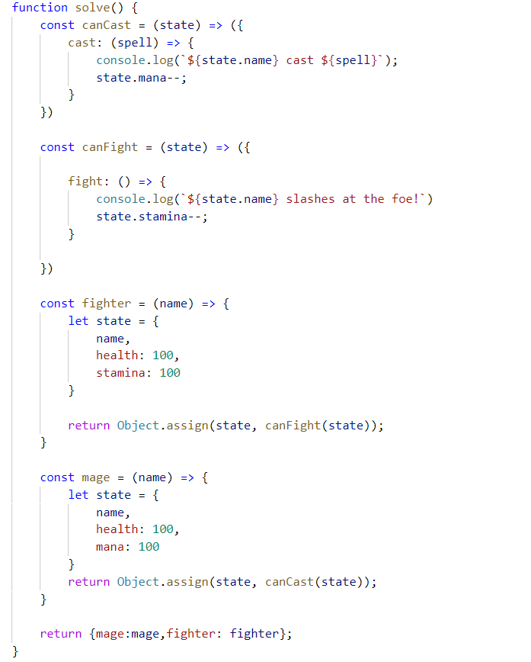

## Jan's Notation *

Write a program that parses a series of instructions written in **postfix notation** and executes them (postfix means the operator is written **after** the operands). You will receive a **series of instructions** – if the instruction is a **number**, **save it**; otherwise, the instruction is an **arithmetic operator**(**+-*/**) and you must apply it to the most two **most recently saved** numbers. **Discard** these two numbers and in their place, **save the result** of the operation – this number is now eligible to be an **operand** in a subsequent operation. Keep going until all input instructions have been exhausted, or you encounter an **error**.

In the end, if you’re left with a **single saved number**, this is the **result** of the calculation and you must **print** it. If there are more numbers saved, then the user supplied **too many instructions** and you must print "**Error: too many operands!**". If at any point during the calculation you **don’t have** two numbers saved, the user supplied **too few instructions** and you must print "**Error: not enough operands!**". *See the examples for more details.*

### Input

You will receive an array with numbers **and** strings – the numbers will be **operands** and must be saved; the strings will be **arithmetic operators** that must be applied to the operands.

### Output

Print on the **console** on a single line the **final result** of the calculation or an **error message**, as instructed above.

### Constraints

* The **numbers** (operands) will be integers
* The **strings** (operators) will always be one of **+-*/**
* The result of each operation will be in the range [-253…253-1] (**MAX_SAFE_INTEGER** will **never** be exceeded)

### Examples

|  |  |  |
| --- | --- | --- |
| **Input** | **Output** | **Explanation** |
| **[3,**  **4,**  **'+']** | **7** | The first instruction is a **number**, therefore we **save** it. The next one is also a **number**, we **save** it too.  The third instruction is a **string**, so it must be an **operator** – we **remove the last two** numbers we saved, and perform the operation: **3+4=7**. The result of this operation is then **saved** where the two operands **used to be**.  We’ve run out of instructions, so we check the saved values – we only have **one**, so this must be the **final result**. We **print** it on the console. |
| **[5,**  **3,**  **4,**  **'*',**  **'-']** | **-7** | We save in order **5**, **3** and **4**. The result of the operation **3*4** is **12**, which we **save in place** of **3** and **4**.  Currently, we have **5** and **12** saved. The result of the operation **5-12** is **-7**, which we **save in place** of **5** and **12**.  We have no more instructions and **only one** value saved, which we **print**. |

|  |  |  |  |  |
| --- | --- | --- | --- | --- |
| **Input** | **Output** |  | **Input** | **Output** |
| **[7,**  **33,**  **8,**  **'-']** | **Error: too many operands!** | **[15,**  **'/']** | **Error: not enough operands!** |